

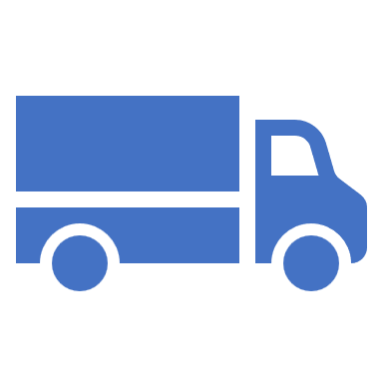

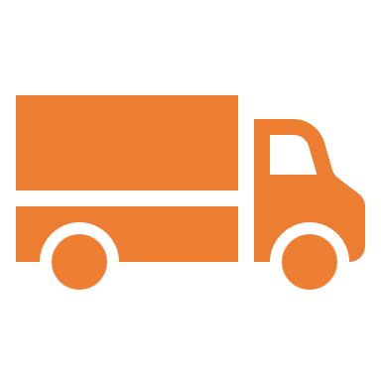



PoC Scope of Work Document
for
Ashok Leyland

Submitted on - March 10, 2025

Corporate HQ
Axestrack Software Solutions Pvt. Ltd.,
Office No.-19, 6th Floor, Jaipur Electronic Market, Near Riddhi Siddhi,
Gopalpura bypass, Jaipur – 302018, Rajasthan, India

Table of Contents
1 Introduction 2
2 Release Notice 2
3 Project Objective 2
4 PoC Scope Mapping 3
5 Our Value Levers 4
6 Business Workflow 5
7 PoC Success Criteria 6
8 Pre-requisite 7
9 Annexure A – Overview on Value Levers 8
9.1 Gate Entry/Exit Dashboard 8
9.2 AI True Lead Distance 8
9.3 AI True Halts/Locations 9
9.4 Geofence/ Toll Visibility 9
9.5 Deviation Clusters 10
9.6 Xsight Dashboard 10
9.7 Reverse Logistics 11
10 Annexure B – Industry Best Practices & Additional Benefits 12
10.1 Our Offerings 12
10.2 AI Control Tower 12

Introduction
Axestrack is grateful to ‘Ashok Leyland’ for the opportunity to conduct a proof of concept (POC). With our distinctive value proposition and deep expertise, we are committed to elevating Ashok Leyland to new heights and delivering an exceptional digital experience.

Release Notice
Company | Location | Industry
Ashok Leyland | TBD | Automobile

Project | PoC Start Date | PoC Location
Track & Trace along with Managed Control tower solution | TBD | TBD

 | Name | Contact Number | Email Id
PoC Initiated by
Ashok Leyland SPOC
Axestrack SPOC (L1)
Axestrack SPOC (L2)

Project Objective
- Track & Trace through Dedicated GPS/ API
- Multimode Tracking with Auto Fail Safe Engine
- AI based Unloading Identification
- AI based True-Lead distance
- GPS uptime
- Managed Control Tower (MCT) Set-up for Real-time Intervention for Deviation/Detention/Uptime management/Safety violation
- ePOD
- Business analytics
- Safety Reports for Speed violation/Night driving/Continuous driving/HOS Reports
- Auto Alerts

PoC Scope Mapping

Trips | 30 Trips (Dedicated GPS Devices)
PoC Duration | 15 Days

Trip Type
Inbound Outbound
GPS Track & Trace
Market Vehicle Dedicated Vehicle ☐
Tracking Mode
SIM ☐ API ☐ Fixed GPS ☐ Plug & Play GPS
ADAS/DMS ☐
CPL ☐
Route Module ☐
ULIP Toll Visibility
Trip Creation
Manual Integration ☐ Geofence ☐
ePOD
Managed Control Tower
Reverse Logistics

Our Value Levers
Value Creation Levers | Definition | Impact
Gate Entry/Exit Dashboard | When a vehicle enters the plant, the system utilizes GPS technology to automatically capture and verify all relevant vehicle and driver information | Compliance with Safety  Enhanced Visibility
AI True Lead Distance | The true distance with 99.9% accuracy, resolving GPS jump issues in real time between origin and destination points | Saves Cost  Customer SLA Compliance
AI True Halts/Locations | The exact name of the halt type viz, dhaba, petrol pump, general parking, etc. while shipment transit | Pilferage Prevention  Arrest Leakage
Geofence Toll Visibility | Availability of Geofence toll approx. Tarriff incurred during shipment transit (Recommended) | Cost Optimization  Route Optimization
Deviation Clusters | Clear insight into the deviation by delivery location, kms and percentage impact | Cost Optimization  Route Optimization
Xsights Dashboard | Enables faster decision-making ability for the management | Better Decision Making  Track Health Monitor
ePOD | Digital receipt for delivery confirmation which helps in reducing the transporters bill submission/material shortage/mismatch | Digitization for Delivery  Confirmation & TAT Optimization
Reverse Logistics | Fully managed Reverse Logistics for rotational inventory availability at plant | Never Stock-Out  Minimal Device Lost

Business Workflow
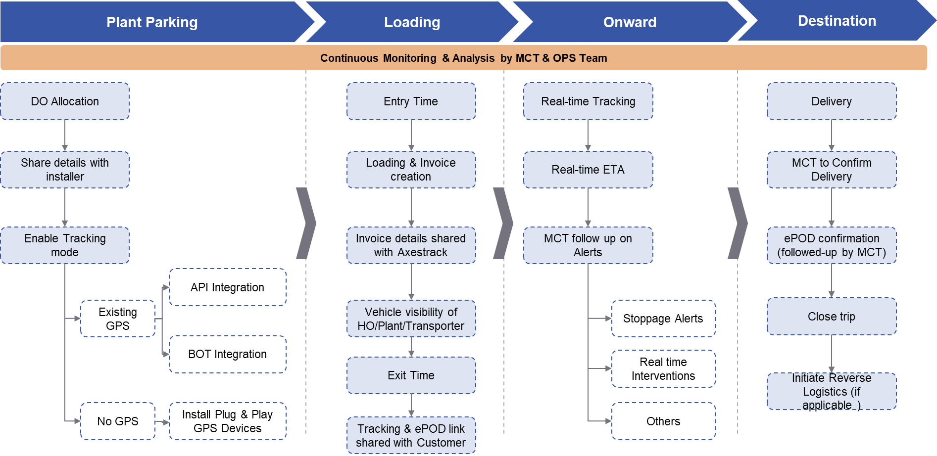
Note :
- In case of damage/tampering of the hardware/loss of the hardware during the trip, Client will be responsible for the same.

PoC Success Criteria
Sr. No. | Success Parameter | Success Criteria
1 | Tracking Coverage & Visibility | - 100% visibility of valid trips on Axestrack platform.  Note: - OEM fitted GPS downtime will not be considered
2 |  | - 90%+ Tracking quality of every trip.  Note: - Depends on another GPS provider uptime.
3 | Managed Control Tower | - Alert & Exceptions handling  - Enroute Stoppage,  - ETA Delay
4 | Lead Distance Validation | - Correction in SAP Lead Master by comparing True Lead vs Existing SAP Lead
5 | Analytics & Support | - Actual Travelled distance  - Deviation Summary  - TAT Summary  - Trip Summary  - Stakeholder's query, problem resolution and explore ways to improve adoption  - AI Data enrichment
6 | Reverse Logistics | - Fully managed Reverse Logistics to maintain sufficient rotational inventory at plant

Pre-requisite
  - Dedicated SPOC from Ashok Leyland Plant with contact no & email
  - Escalation Matrix
  - Necessary Plant access approvals/permissions for Axestrack officials
  - Transporter SPOC with contact details
  - Timely Trip Data Sharing (within 1 hr of trip allocation)
  - Type of alerts
  - Any additional support during the PoC can be managed on mutual consent

Annexure A – Overview on Value Levers

Gate Entry/Exit Dashboard
Upon vehicle entry, the system uses GPS technology to gather comprehensive vehicle data. If driver details are already recorded, they will be displayed on the dashboard; otherwise, there is an option to manually input the driver's information. This real-time data collection enhances compliance with safety standards and improves operational transparency, streamlining the gate entry process and providing better visibility and control for efficient plant management.
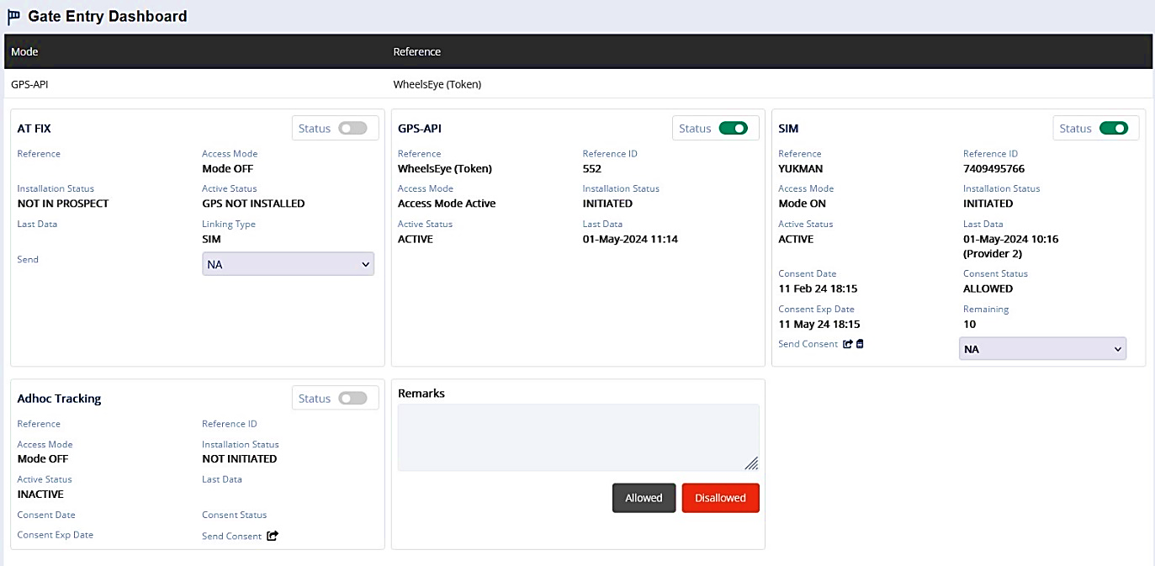

AI True Lead Distance
AI True Lead Distance calculates the precise distance between origin and destination with 99.9% accuracy. By using advanced algorithms, it resolves GPS jump issues in real-time, ensuring consistent and reliable data for optimal route planning and analysis. This innovative approach enhances efficiency and accuracy in distance measurement.
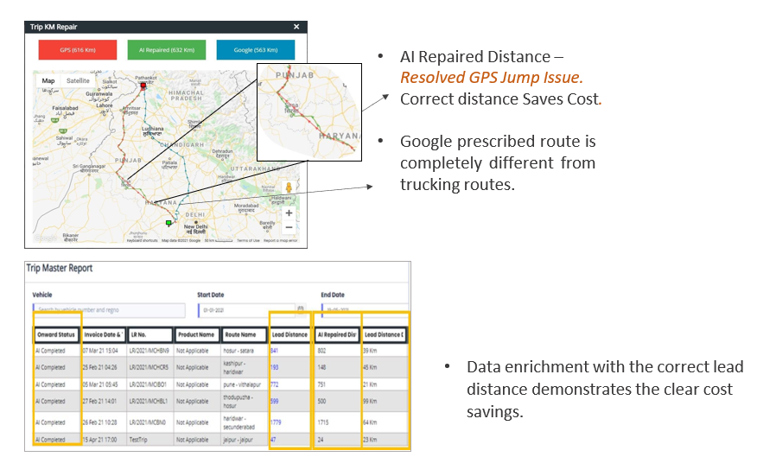

AI True Halts/Locations
AI True Halts/Locations identifies and classifies the specific types of stops made during shipment transit, such as dhabas, petrol pumps, and general parking areas. By accurately pinpointing these halt locations, the system provides detailed insights into the journey, helping optimize route planning and improve overall efficiency during transit.
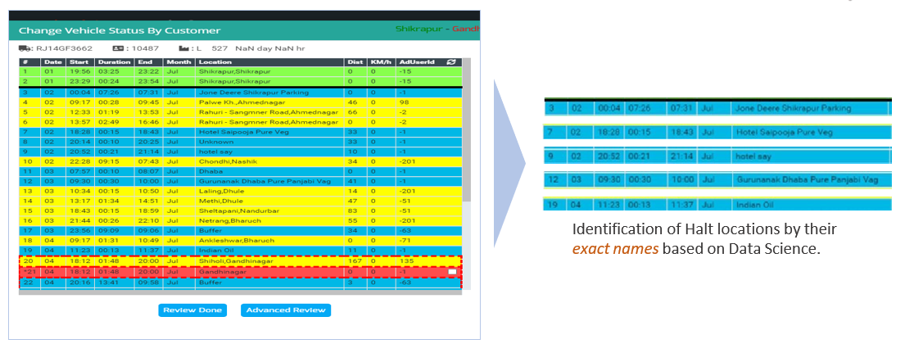

Geofence/ Toll Visibility
Geofence Visibility offers detailed insights into toll costs incurred during shipment transit. By mapping out geofenced toll zones, the system provides real-time data on approximate tariffs, aiding in budgeting and route optimization. This feature is recommended for precise cost management and enhanced efficiency during transportation.
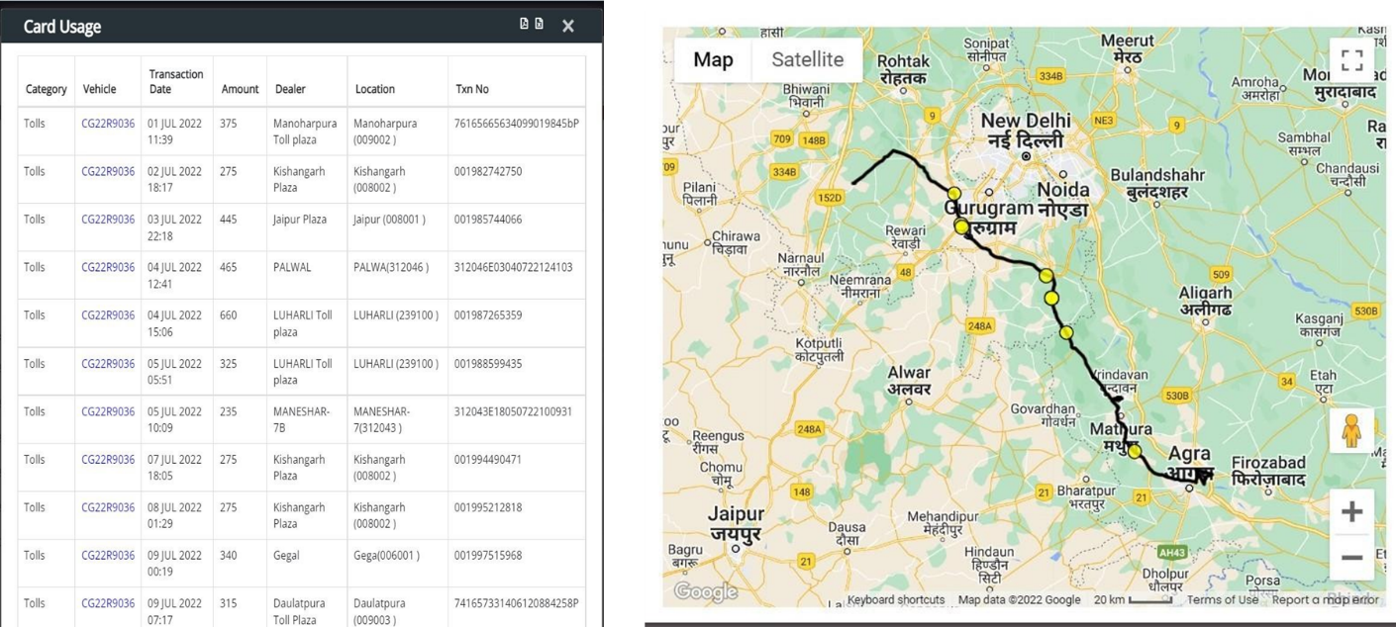

Deviation Clusters
Deviation Clusters provide clear insights into delivery route deviations by analyzing location, distance, and impact percentage. This data helps identify areas where deviations occur, allowing for targeted improvements in route planning. By understanding these clusters, businesses can enhance efficiency, minimize costs, and improve overall delivery performance.
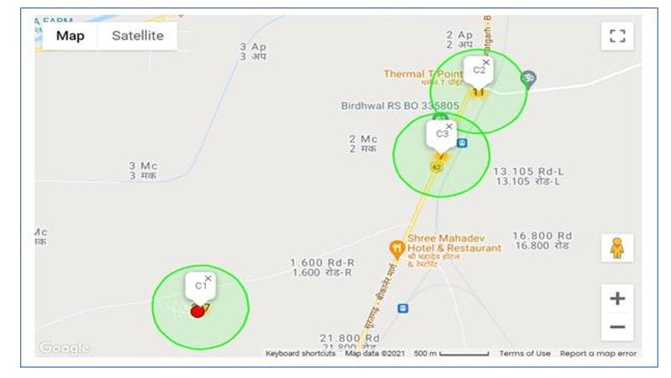

Xsight Dashboard
The Xsight Dashboard empowers management with quick and efficient decision-making capabilities. By presenting real-time data and actionable insights in a clear, user-friendly format, the dashboard streamlines analysis and supports informed choices. This enhances operational control and strategic planning, leading to improved performance and productivity.
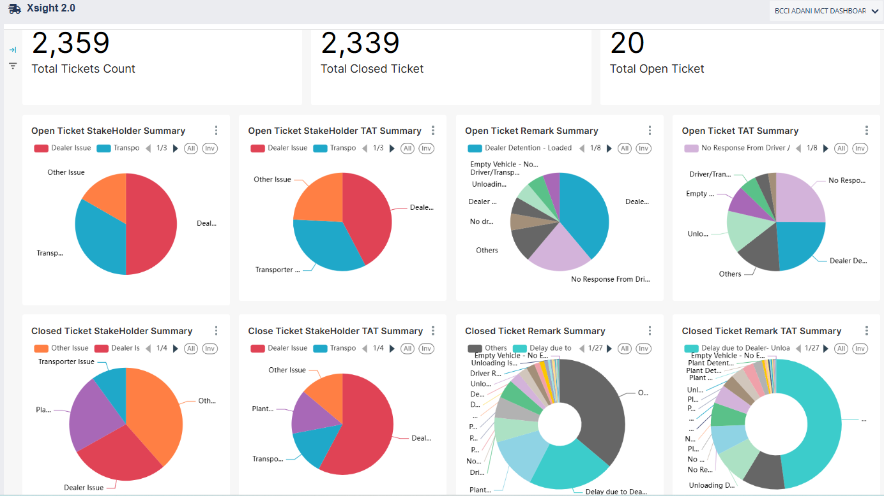

Reverse Logistics
With the support of our in-house designed Inventory Management Dashboard, we effectively manage the entire inventory in the Reverse Logistics process, ensuring continuous device availability at the plant and eliminating any risk of stock-outs.
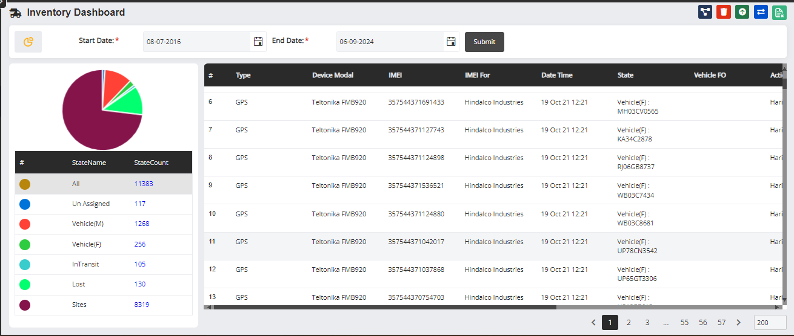

Annexure B – Industry Best Practices & Additional Benefits

Our Offerings
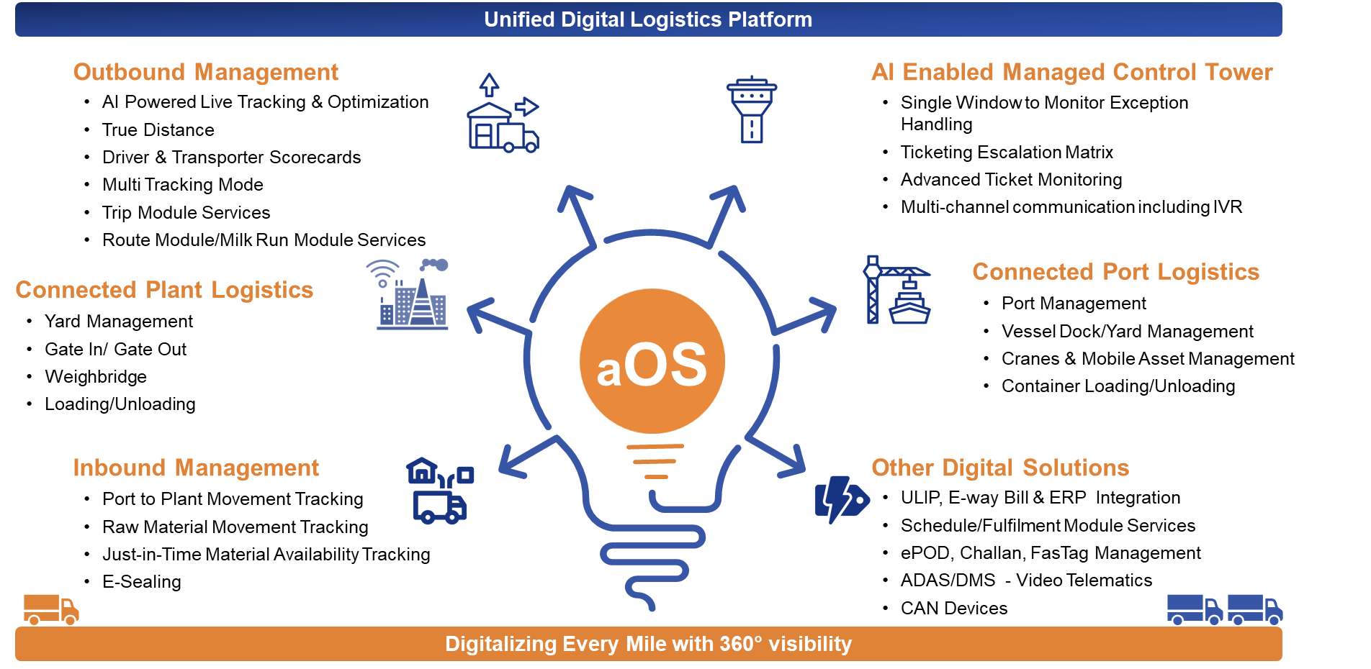

AI Control Tower
The AI Control Tower offers a comprehensive overview of shipment transit via road, providing a bird's-eye view of the entire operation. By monitoring and controlling events in real time, the system enhances situational awareness and ensures smooth transit. This advanced oversight optimizes logistics, improves efficiency, and mitigates potential disruptions.
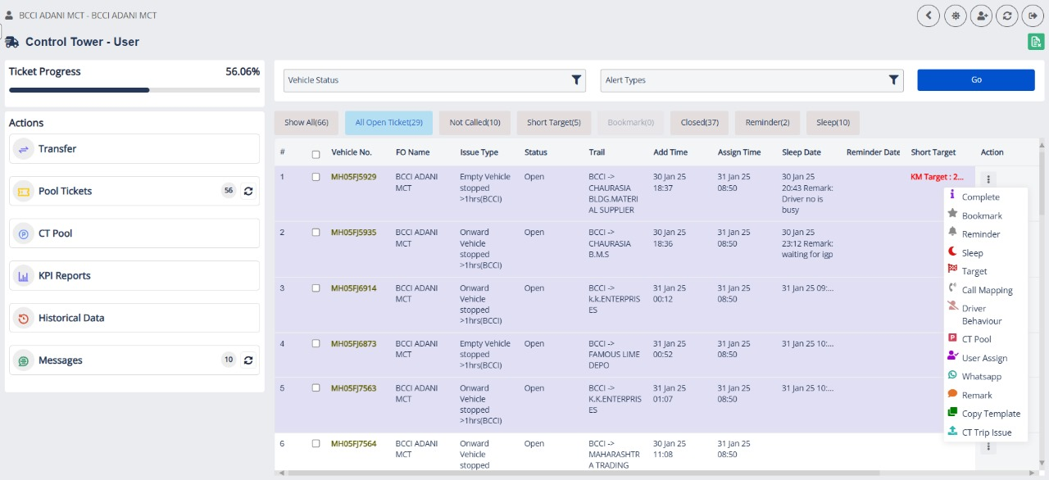


www.axestrack.com
www.

